**AWS Regions (Geographically Location) and Availability Zones (Data Center):-**

**What are AWS Regions?**

AWS Regions are separate geographic areas that AWS uses to house its infrastructure. These are distributed around the world so that customers can choose a region closest to them in order to host their cloud infrastructure there (aws ping) command. The closer your region is to you, the better, so that you can reduce network latency as much as possible for your end-users. You want to be near the data centers for fast service.

**What AWS Regions have the most services?**

Not all regions are created equally. These regions have more services than others in their general areas:

**Americas: US East (N. Virginia), US West (N. California)**

**Asia Pacific:  Singapore, Sydney, Tokyo**

**EU: Frankfurt, Ireland**

**Availability Zones---Data Center**

AZs are essentially the physical data centers of AWS. This is where the actual compute, storage, network, and database resources are hosted that we as consumers provision within our Virtual Private Clouds (VPCs). A common misconception is that a single availability zone is equal to a single data center. In fact, it’s likely that multiple data centers located close together form a single availability zone.

Each AZ will always have at least one other AZ that is geographically located within the same area, usually a city, linked by highly resilient and very low latency private fiber optic connections. However, each AZ will be isolated from the others using separate power and network connectivity that minimizes impact to other AZs should a single AZ Fail.

AZ latency for normal are 0.5 mile/sec.

Notes:- AZ’s are physically separated by a meaningful distance, many kilometers, from any other AZ, although all are within 100 km (60 miles)

**What is an AWS availability zone composed (requirements)of?**

An Availability Zone (AZ) is one or more discrete data centers with

* Redundant power --------------Mahavitaran, Adani, Reliance
* Redundant Networking (ISP), -----------Airtel, Jio, Vodafone
* Connectivity in an AWS Region.
* Multiple AZ OR DC are not in same building.

**CDN (Content Distribution network) -Caching/PoP/Edge**

You can use a content delivery network (CDN) such as [Amazon CloudFront](https://docs.aws.amazon.com/AmazonCloudFront/latest/DeveloperGuide/) to serve the content that you store in AWS Elemental Media Package. A CDN is a globally distributed set of servers that caches content such as videos. When a user requests your content, the CDN routes the request to the edge location that provides the lowest latency. If your content is already cached in that edge location, the CDN delivers it immediately. If your content is not currently in that edge location, the CDN retrieves it from your origin (in this case, the Media Package endpoint) and distributes it to the user. The following illustration shows this process.

**AWS High Availability**

High availability (HA) is a system’s ability to function even when some components fail. High availability guarantees continuous operability of systems for desirably long periods of time. A solid requirement for enterprises, high availability protects businesses against the risks brought by a system outage.

High availability for systems is represented through a sequence of “9’s”. A 100% availability translates to 0 minutes of downtime in a year, which is practically infeasible and an ideal benchmark. A three-nines availability, represented as 99.9%, allows 8 hours and 46 minutes of downtime per year. A four nine availability, 99.99%, allows 52 minutes and 36 seconds downtime per year, and a five-nine availability, which is the accepted standard for emergency response systems and mission-critical operations, provides about 5 minutes and 15 seconds of downtime per year.

**Advantages of Using AWS High Availability** for Web Applications

AWS high availability for web applications provides you with the following benefits:

* A completely secured network that uses a Web Application Firewall (WAF) to prevent common web exploits.
* AWS HA has provisions like Business Continuity (BC) and Disaster Recovery (DR) technologies to help businesses resume operations with minimal disruption.
* For cases where instant hardware failure may arise or are about to arise, AWS Auto Scaling automatically detects this and launches a new instance.
* AWS HA provides metrics on the cloud to closely monitor the application based on the number of users using the application or the memory consumed by the particular instance.
* The deployment of new features or updates may be done without causing any problems for present users.

**Disaster Recovery**

Backup and restore. Backup and restore is a suitable approach for mitigating against data loss or corruption. This approach can also be used to mitigate against a regional disaster by replicating data to other AWS Regions, or to mitigate lack of redundancy for workloads deployed to a single Availability Zone.

Disaster recovery as a service (DRaaS) model that allows an organization to back up its data and IT infrastructure in a third-party cloud computing environment and provide all the DR orchestration, all through a SaaS solution, to regain access and functionality to IT infrastructure after down the setup.

In disaster recovery architectures, resources are usually duplicated and replicated to a different data center and geographical region to ensure that they are far enough away from the source of the disaster.

**Types of disaster recovery**

* Data center disaster recovery. ...
* Network disaster recovery. ...
* Virtualized disaster recovery. ...
* Cloud disaster recovery. ...
* Disaster recovery as a service (DRaaS)

**Difference between High Availability (HA) & Disaster Recover (DR):-**

Both availability and disaster recovery rely on some of the same best practices, such as monitoring for failures, deploying to multiple locations, and automatic failover. However, Availability focuses on components of the workload, whereas disaster recovery focuses on discrete copies of the entire workload.

**What is an Outpost in AWS :-**

AWS Outposts is a completely managed service that provides the same AWS services, infrastructure, APIs and tools to virtually any datacenter, or a co-location space, or any on-premises facility which gives enterprises the truly hybrid experience.

AWS Outposts is perfect for the mission-critical workloads which need low latency access to on-premises systems, compliance to data residency requirements, local data processing, and migration and modernization of applications with local system interdependencies.

AWS storage, database, compute, and other crucial services run locally on Outposts and enterprises can use the full range of AWS cloud services available in the region to manage, build, and scale the on-premises applications with AWS tools and services.

**Benefits for AWS Outputs**

* Store and process Data on

Premises.

* Truly Consistent hybrid

Experience

* Fully managed Infra.

**Requirements for AWS outpost Setup: -**

|  |  |
| --- | --- |
| **AC line voltage** | Single-phase 208 to 277 VAC (50 or 60 Hz)  Three-phase 346 to 480 VAC (50 to 60 Hz) |
| **Power consumption** | 5 kVA (4 kW), 10 kVA (9 kW), or 15 kVA (13 kW) |
| **AC protection (upstream power breakers)** | 30 A or 32 A with D-curve circuit breaker |
| **AC inlet type (receptacle)** | Single-phase 3xL6-30P, P+P+E, 30A or 3xIEC60309 P+N+E, IP67, 32A plugs  Three-phase, Wye 1xIEC60309, 3P+N+E, IP67, clock position 7, 30A plug or 1xIEC60309, 3P+N+E, IP67, clock position 6, 32A plug  Three-phase, Delta 1xNon-NEMA twistlock Hubbell CS8365C, 3P+E, center ground, 50A plug  Note  The best practice is to mate an IP67 plug with an IP67 receptacle. If that isn't possible, the IP67 plug will mate with an IP44 receptacle. The rating of the combined plug and socket will become the lower rating (IP44). |
| **Whip length** | 10.25 ft (3 m) |
| **Whip - Rack cabling input** | From above or below the rack |

**AWS Wave length Zone:-** Wavelength Zones are AWS infrastructure deployments that embed AWS compute and storage services within telecommunications providers' data centers at the edge of the 5G network, so application traffic can reach application servers running in Wavelength Zones without leaving the mobile providers' network. 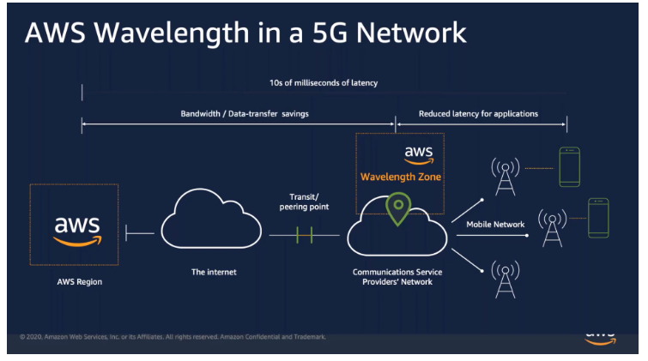

**AWS Local Zone:-** AWS Local Zones are a type of AWS infrastructure deployment that place compute, storage, database, and other select services closer to large population, industry, and IT centers, enabling you to deliver applications that require single-digit millisecond latency to end-users.

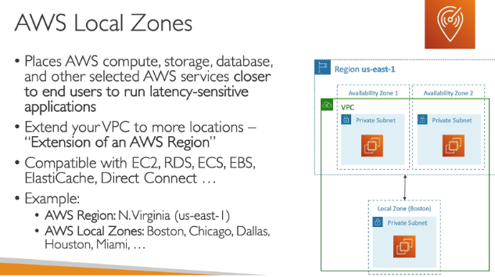

**AWS Outpost/AWS Local Zones/AWS Wavelength**

